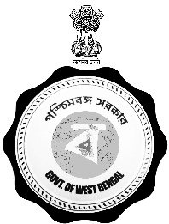

Government of West Bengal
Irrigation & Waterways Directorate
Office of the Executive Engineer
Metropolitan Drainage Division No.-I
Jalasampad Bhawan (4th Floor), South Block
Bidhannagar, Salt Lake City, Kolkata – 700091.
E-mail – executiveengineermdd1@gmail.com

CORRIGENDUM - 1

Memo No.: – 1T-1/1228 Dated :- 06/06/2023

- In partial modification of e-NIT No. - WBIW/EE/MDD-I/e-NIT- 04/ 2023 – 24 , SL. NO. 06,
( Tender ID :- 2023_IWD_531809_6 ) vide circulated Memo. No. 1T-1/1144 dated 18/05/2023, the following changes have been made, this is for wide circulation.

Sl. No. | Activity | Date & Time  (To be Read as) | Date & Time  (In Place of) | Remarks
1. | Document Download end date | 09/06/2023 at 11:00 Hrs. | 06/06/2023 at 11.00 Hrs.
2. | Bid submission end date | 09/06/2023 at 11:00 Hrs.. | 06/06/2023 at 11.00 Hrs.
3. | Technical Bid opening date with preliminary result (TBO Sheet ) | 09/06/2023 at 14:00 Hrs.. | 06/06/2023 at 14.00 Hrs.

Sd/-
Executive Engineer Metropolitan Drainage Division-I
Jalasampad Bhawan, (4th floor).

